Background on the Oculina Coral Habitat Area of Particular Concern; Why Recreational Fishermen Should Care
May 23, 2022

Summary

On April 29 The National Marine Fisheries Service of the National Oceanographic and Oceanic Administration (NOAA) published an Amendment to a fisheries management plan in the Federal Register that proposes to re-open part of an area known as the Oculina Bank Habitat Area of Particular Concern (OHAPC). It is called Amendment 10 to the Coral, Coral Reefs, and Hard Bottom Fishery Management Plan (hereinafter “Coral Amendment 10”). Amendment 10 was discussed over a period of years and adopted by the South Atlantic Fishery Management Council despite the unanimous opposition from the Council’s Coral Advisory Panel, several marine and fishery scientists who have studied the area, and a host of local groups. The opponents of Amendment 10 objected to it because it would allow shrimp trawlers into a buffer area next to delicate deep sea Oculina varicosa corals which provide important habitat for many commercially and recreationally valuable species. Bottom trawling right next to the delicate coral banks will inevitable damage them, just like the trawlers did to the 90% of Oculina destroyed in 1970s and 1980s. Today, the remaining Oculina reef is the site of spawning for three fish: gag, snowy grouper, and red porgy that are all overfished and valued by recreational fishermen. The reef is also important habitat for adults and juveniles who find protection and abundant prey in and among the corals.

Damage from bottom trawling
Despite these concerns, the South Atlantic Fishery Council approved Coral Amendment 10 in November 2021. The amendment would permit bottom trawling on a “buffer strip” inside the OHAPC, directly adjacent to the fragile coral ecosystem. In addition to damaging any potential coral recovery in the 22 square-mile buffer strip, trawling in the buffer will cause harm to the sensitive corals adjacent to the buffer strip:
- Sediment plumes from nearby trawling will damage the Oculina coral, disrupting their ability to filter feed and preventing juvenile recruits from settling. According to evidence presented by the South Atlantic Council’s Coral Advisory Panel and several scientists who have studied the Oculina, underwater currents in this area can be very strong and flow westerly, that is, from the buffer strip onto the remaining living corals.
- Wayward trawls will damage corals outside the intended trawling area. Heavy shrimp trawling nets are difficult to always position correctly at depths of 200–300 feet, especially with the strong and variable cross currents typical of this area. Inaccuracy in tracking the nets’ swath compounds these issues. National Marine Fisheries Service data conservatively estimates there can be 230 to 510 horizontal meters between the fishing trawl on the bottom and the trawling boat; the proposed fishing area is only 150 to 600 meters wide. Hence, the heavy gear is likely to, at least occasionally, crush and destroy healthy coral outside the intended trawl zone.
For these reasons, the existing buffer strip needs to be preserved. It is doing what it was designed originally to do: keep bottom gear and sediment away from sensitive corals. There simply is no replacement for the workings of a buffer strip in this case.

Damage to fishing and marine life

This area of deep sea corals was first protected from bottom trawling by NOAA in 1984 after 90% of the coral reef had been destroyed by shrimp and other trawlers in the 1970s and 1980s. According to fishery scientists, this shelf-edge region is also an important spawning ground for several snapper-grouper species. The complex coral habitat serves to protect and nurture juveniles and adults who forage for the abundant prey that grow in and near the corals. By some estimates a total of 2,000 species of all kinds live on an among the corals, creating a rich ecosystem that the snappers-groupers forage in. A great deal of recreational fishing occurs in the Oculina HAPC. The corals are also important for fish populations as close as the Indian River Lagoon and as far away as North Carolina where tagging has shown some individuals travel from to spawn.

Several of the recreational fish species targeted at and supported by the habitat of the OHAPC –snowy grouper, gag, and red porgy— are prized by recreational fishermen in Florida and the South Atlantic and are listed as overfished or experiencing overfishing by the latest NOAA Status of Stocks report. Destroying habitat for overfished species on rebuilding plans is not a good idea and could lengthen the rebuilding period and/or reduce the allowable catch limits for the species during the rebuilding period. Neither would be good for recreational fishermen.

Economic importance of saltwater recreational fishing and fishermen in Florida
According to a report from the Florida Fish and Wildlife Conservation Commission, saltwater recreational fishing and fishermen have a large impact on the state’s economy. In total saltwater fishing generates:
- 1.5 million saltwater recreational licenses sold in fiscal year 2019/20202.
- 4 million recreational resident and nonresident who had an active license in fiscal year 2019/2020
- Saltwater recreational fishing generated: $9.2 billion*
- Supports: 88,501 jobs* (saltwater only)
*Source: American Sportfishing Association and Southwick Associates, based on USFWS 2011 survey data updated to 2020 using FWC-OLP’s license trend data plus inflation data

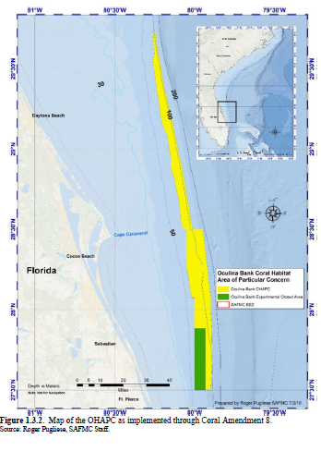
Source: South Atlantic Fishery Management Council (August 2021), Draft Amendment 10 for the fishery management plan for coral, coral reefs, and hard bottom of the South Atlantic region; Establish a shrimp fishery access area along the northern border extension of the Oculina Bank HAPC: Environmental Assessment. Accessible at: https://repository.library.noaa.gov/view/noaa/33464

